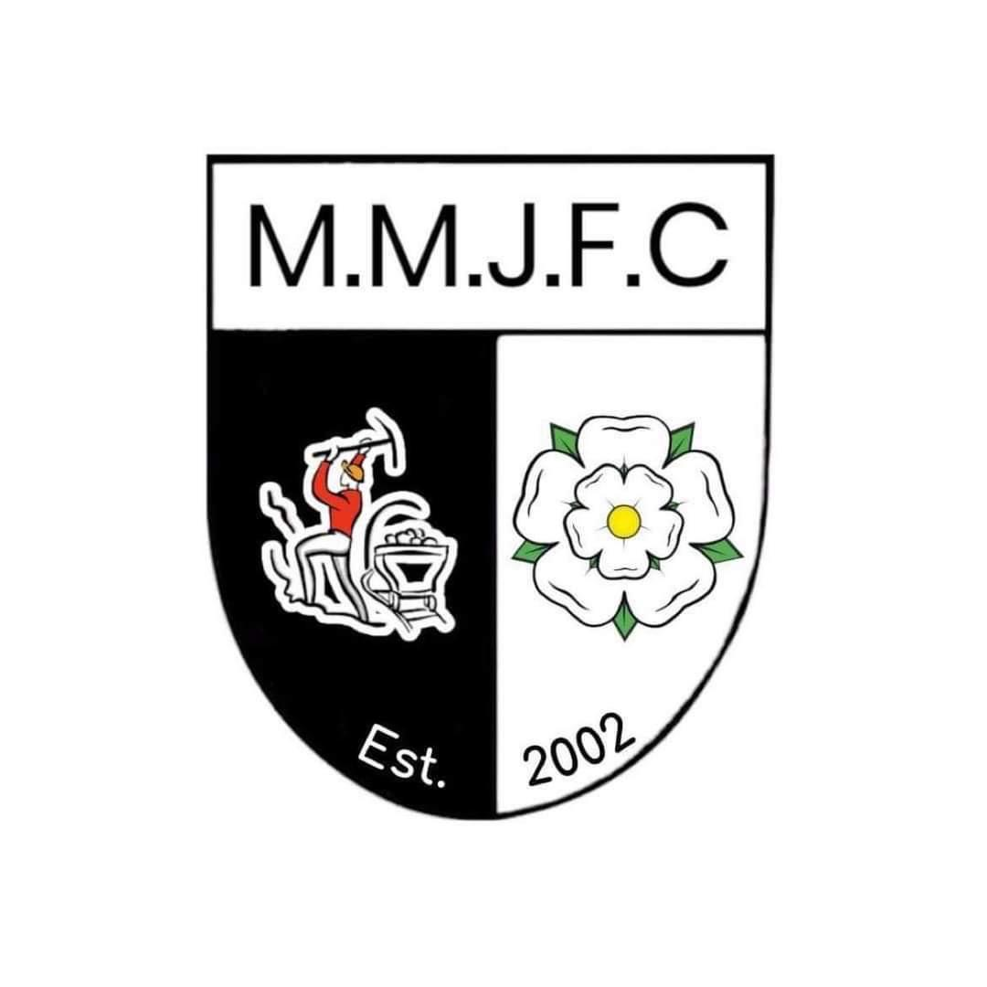

MALTBY MAIN JUNIORS FOOTBALL CLUB

SOCIAL MEDIA POLICY
At Maltby Main Juniors Football Club (MMJFC), we recognise that social media platforms such as Facebook, Instagram, TikTok, and X (formerly Twitter) are an integral part of daily life and offer fantastic opportunities for communication and promotion. However, we also acknowledge the potential for these platforms to be misused in a way that can damage relationships, reputations, and the club’s values.
This policy sets out clear expectations for players, parents/carers, coaches, and committee members when using social media. It is designed to safeguard our members, protect the reputation of MMJFC, and ensure we operate with respect and responsibility at all times.

General Guidance
This policy applies to all members of MMJFC. Where a specific platform is not mentioned, the principles of this policy still apply. If in doubt, please consult your team manager or the Club Welfare Officer.

Using Social Media Personally
When using personal social media accounts, members are expected to:
- - Protect their privacy: Adjust privacy settings so that only approved friends or followers can view posts.
- - Think before posting: If you wouldn’t say something to someone’s face, don’t post it online.
- - Be cautious with connections: Avoid accepting friend or follow requests from people you do not know, particularly minors or individuals from other teams.
- - Respect your role: Whether you are a parent, player, coach, or volunteer, you are seen as a representative of MMJFC. Your behaviour online should reflect this.
- - Include disclaimers where appropriate: If discussing football or club matters, clarify that the views expressed are your own and not those of MMJFC.
- - Uphold confidentiality: Do not share personal or sensitive club matters, including internal decisions, financials, or safeguarding issues.
- - Respect copyright and consent: Do not share images, videos, or information about players, parents, or club members without prior consent. Especially avoid identifying children by full name.

Respect for Others
We expect all members to:
- - Treat other players, parents, coaches, referees, and committee members with courtesy and respect online, as they would in person.
- - Avoid posts or comments that could be seen as bullying, inflammatory, offensive, or libellous.
- - Refrain from using MMJFC’s name, branding, or logos without written permission from the Club Committee.
- - Report any concerning online activity related to the club to your team manager or the Club Welfare Officer.
Misuse of social media that violates this policy may result in action being taken by the committee, including removal from the club if necessary.

Use of Official Club Accounts
MMJFC manages its own official social media accounts to promote club news, events, fundraising, and achievements.
- - Official accounts must be approved by the Club Committee and documented in meeting minutes.
- - Only authorised individuals may post on behalf of the club.
- - No photos, names, or media identifying children will be published without appropriate parental/carer consent.
- - Media must not include personal information such as full names or addresses of children.

Publishing Match Results
In line with FA and league guidance:
- Match results for teams under U12s must not be published online—this includes posts by coaches, parents, or supporters.
- Any doubt about what can be shared should be discussed with your team manager or a committee member.

Final Note
As a member of Maltby Main Juniors FC, you are an ambassador for the club. Your online behaviour should reflect the values of respect, inclusion, and community. What you post online can impact others and the reputation of the club—please use social media responsibly.

